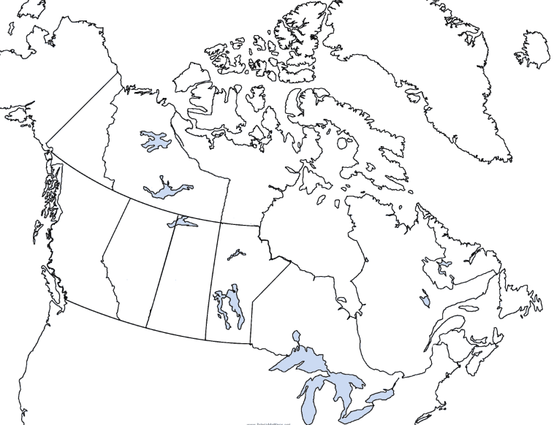
1. ________________________
2. ________________________
3. ________________________
4. ________________________
5. ________________________
6. ________________________
7. ________________________
8. ________________________
9. ________________________
10. ________________________
11. ________________________
12. ________________________
13. ________________________

Province | Capital City
Nunavut
Northwest Territories
Yukon
British Columbia
Alberta
Saskatchewan
Manitoba
Ontario
Quebec
New Brunswick
Nova Scotia
Prince Edward Island
Newfoundland

